January 15, 2018
Princeton University

Freshman Seminar 151: Time Capsules for Climate Change
Peter Taylor
The following time capsules are the end result of the semester-long course FRS 151: Time Capsules for Climate Change. Taught by distinguished climate scientist Dr. Robert Socolow, Senior Research Scholar and Professor Emeritus of Mechanical and Aerospace Engineering at Princeton University, the class is categorized under the STN label, meaning that it fulfills the Science and Technology without a Lab distribution requirement that all Princeton undergraduates must complete in order to graduate. This course, however, was no normal STN. Though the lecture material and many of our weekly assignments had a scientific foundation and quantitative focus, Professor Socolow gave us extensive freedom in defining and focusing in on our individual topics of research, all focused on some aspect of the global climate crisis. All of our papers are rooted in some scientific area, but we examined our topics from a broad range of angles: biological, social, political, technical, economic, and, perhaps most of all, personal. The crux of the course, however, is the final assignment, which asks students to take a topic that they have researched throughout the semester and write not only a thorough overview of its nuances from any number of potential angles but to lay out two potential scenarios of how such an overview might look in four separate moments: our graduation from Princeton in 2022 and our class reunions in 2032, 2047, and 2072. At these times, we will open the capsules to reread our papers and evaluate the comparison between our predictions and the current state of affairs.
Though the idea was simple in theory and exciting in prospect, the reality of the projects became a thrilling challenge for each of us as we predicted how a fraction of the world’s landscape will one day differ from now. Professor Soclow began the course by stating a number of goals. First, he hoped that we would gain a greater facility with reading scientific literature, something none of us had ever really been exposed to. Secondly, he wanted us to leave the course understanding that science is not just something theoretical, but rather something performed by people, and the numbers and solutions to problems are not just collections of digits but rather quantitative representations of the real world. Professor Socolow encouraged us to look at our own topics of research from a quantitative angle but ultimately be guided by our own personal interests and connections. At the end of the first class, Professor Socolow assured us that, though the project may at first seem daunting, by the end of the semester we would be in as authoritative a position as anyone who researches in the field to make predictions about the future. Grace Barbara looks back on the first class with extreme fondness: “Honestly, class one made the biggest impact on me. Our visitors and field trips, of course, stuck out, but class one seriously removed me from my safe bubble and put me into this situation in which I have never been before.”
Our individual class sessions often each followed a broad theme of which Socolow would give us a basic overview to serve as a springboard for further thought, examples of which include solar power, wind energy, and global climate patterns, the reins on multiple occasions handed to Aaron Match, a Princeton graduate student helping Professor Socolow with the class. Many of our classes, however, featured some kind of guest or special event, such as a visit to Mudd Library, where these capsules are stored, or a tour of the University’s power grid. One truly memorable class session was the visit of New Jersey legislator Andrew Zwicker, who led us in an open and extraordinarily candid discussion about politics in a manner that was uncharacteristic of a stereotypical politician. Yael Stochel “especially enjoyed meeting Andrew Zwicker, and hearing a firsthand experience about the intersection between politics and science.
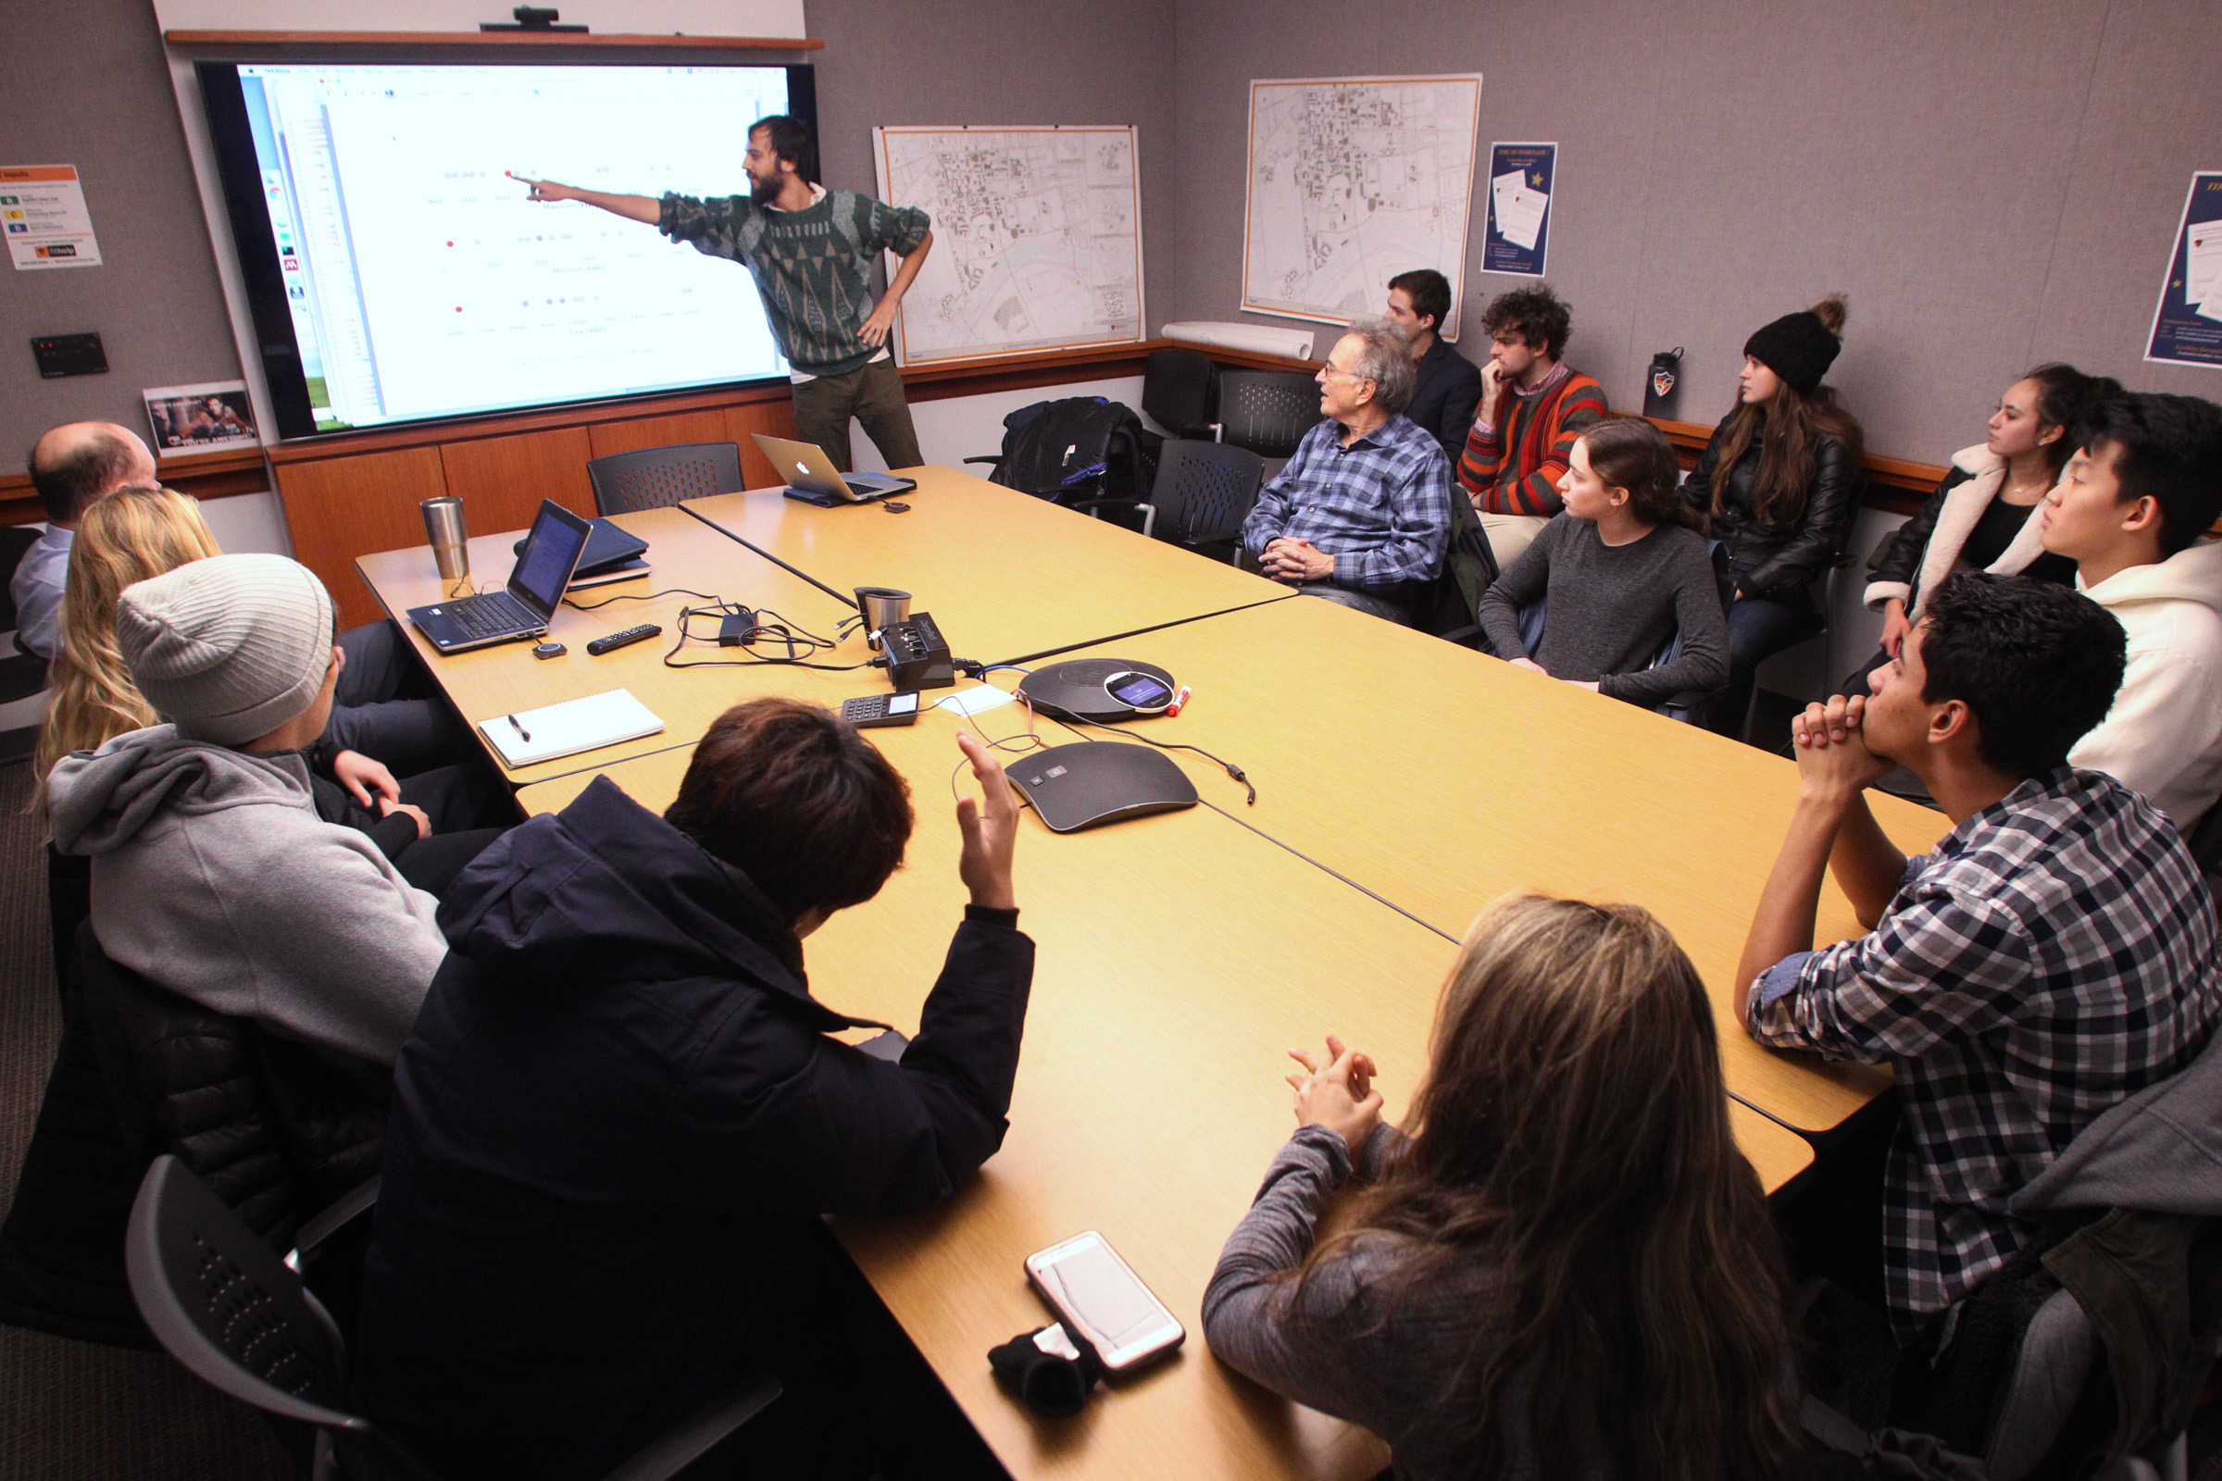
We had discussed more broadly the importance of political action in controlling global warming, but I had not considered the mundane, incremental change that every politician and citizen can demand.” Despite the numerous excellent excursions and visitors, Samantha Bents contends that “The most memorable classes for me were the ordinary ones. Often Dr. Socolow would discuss something particularly thought-provoking relating to climate change, and I would leave the class feeling invigorated with new questions and perspective. That was my favorite part.” The broad scope of the course as a whole maintained a nice balance compared to the specificity of our topics.
We went about choosing our topics in various ways. Some of us, such as Rowan Pierson, wanted to keep a strong scientific focus to their topic, such as his paper on solar energy possibilities in the western United States, specifically Arizona, saying, “The amount of sunlight that hits the Earth in one hour is more than enough energy to power human society for an entire year, so I wanted to learn about the current state of solar and what potential there is in the future to capitalize on this nearly limitless renewable source of energy.” Others, such as Alan Lin, kept a scientific base to their papers, such as in his project about the future possibilities of Arctic shipping, but ultimately expanded into a different kind research. Alan elaborated, saying, “my final product involved much more of the kind of research I would do for a politics class: reading about the history of Russia’s involvement in the Arctic, for example.” Students such as Samantha Bents found a happy medium between the scientific and non-scientific extremes in her paper about the future of climate-intensified malaria, saying, “My initial thought was to only consider the climate when making predictions, and instead I have looked at many other aspects that will affect the problem, such as poverty, foreign aid, and population growth. This has given me much more comprehensive understanding of my topic.” This flexibility of approach ended up giving us a very broad spread of papers to put into our capsule, separating them into three clusters, each of which has its own introductory essay: The Hydrocycle Cluster, The Biosphere Cluster, and The Technology Cluster.
The Freshman Seminar environment was an incredible opportunity to engage in a specific kind of group learning that promoted an exchange of ideas and sense of intellectual solidarity. Though many of us had some initial reservations about the difficulty of the course, particularly in its initial lack of a clear set of expectations in favor of a freer, more open-ended approach, each one of us grew to appreciate the chance to delve so deeply into a single topic of our choosing. Rowan Pierson says specifically, “I have thoroughly enjoyed the independent research that I have been able to do during the seminar, focusing on a single topic throughout most of the semester and feeling now like I am as well versed to talk about that topic as anyone.” In addition to the intellectual opportunity, each of us would agree that we have all formed an incredible bond in working together. Julia Campbell says of the experience, “I really enjoyed the amount of collaboration that was involved in the Freshman Seminar. Our class became pretty strong by the end of the semester because of how much time we spent sharing our ideas and working with one another. This Freshman Seminar has definitely helped me form some lifelong friendships.” As of now, our different views on climate change run the gamut of relatively optimistic to rather pessimistic, but Samantha Bents holds that a common thread is all of our connections to the crisis: “I find this hope from Dr. Socolow, who taught us about potential paths to a solution, but I also find it from many of my classmates. If there are young people as driven, intelligent, and passionate about climate change as my classmates are all around the world, and we are all working together, I truly believe we are capable of stopping climate change.”
We were all intimidated by the prospect of looking at the future, even as we got deep into our topics. Ian Johnson says that the course has forced him to “acknowledge just how opaque the future is,” adding that in regards to how he might come up with an accurate prediction, “Turns out I have no idea. Nor does anyone.” On the other hand, we found an exceedingly special opportunity in the chance to think ahead about the future, especially among such a tight-knit group of students. Rowan Pierson says, “The class is also pretty special because the people you meet in the class you will be connected to for the next 54 years because of reunions and opening the time capsules at the selected dates, so I think for me, I’m excited to have some really good friends as opening the time capsules will not only be a really cool moment to see what predictions I made about climate change as a freshman, but also a great chance to stay connected with friends and reminisce about our shared experiences in FRS 151.” In that sense, the most distinctive aspect of this course- of our course­- is the focus on the future. In our modern society of constant information overload coupled with a high school and university system that often forces us to think in short-sighted, practical terms, we rarely think of ourselves as part of historical current and even less about what our future may look like. This seminar provided us a refreshing opportunity to look ahead, and we are exceedingly grateful for it.
On behalf of our class, we would like to thank numerous individuals who have played an integral role in our learning experience, both in and outside of the classroom. First off, we would like to thank Professor Richard Alley from the Department of Geosciences at Pennsylvania State University whose book The Two Mile Time Machine and subsequent agreement to join our second class session by Skype instigated the first of many fascinating and thought-provoking discussions by our class. We would like to thank the always spiffily-dressed Frank Derby Princeton Class of 1984 for visiting one of our class periods to tell us all about what Princeton reunions look like and to assure us of how much of a treat we can look forward to in having the opportunity to open these capsules during such wonderful celebrations. We would like to thank Tom Nyquist and Ted Borer, Princeton University engineers, for giving us an overview of how energy works at Princeton and a very thorough tour of the facilities. We would like to think Dan Linke of Mudd Library, the dwelling place for centuries of Princetoniana, for making this capsule project possible by giving our capsules not only a physical home for the next five decades but also another enthusiastic supporter. We would like to thank New Jersey legislator and plasma scientist Andrew Zwicker for his frank and open discussion of the current political sphere in New Jersey and the United States and for reminding us that there are good people fighting for good things. We would like to thank Raj Chokshi for her tireless and patient technical support, always there in a pinch whenever we could not figure out even the simplest things. We’d like to thank Caitlin Daley, an administrative assistant with the Princeton Environmental Institute who helped us organize several events, including our final presentations, and always reminding us where we confused first year college students needed to be. We would like to thank Aaron Match, Ph.D. candidate in Princeton’s Program of Atmospheric and Ocean Science and another source of mentorship within the course, always there to give constructively encouraging feedback or just answer any of our questions. And finally, we would like to thank Professor Robert Socolow, a force unto himself, who mentored us as we dove deeper and deeper into our projects, encouraged us even when we doubted ourselves, and gave us an incredible chance to look at the world and our relationship to it in a way none of us had ever really done before. We are all sure that this experience will stay with us throughout the rest of our lives.
Enjoy the capsules.

Peter Taylor, Emily Philippides, Santiago Guiran, Julia Campbell, Grace Barbara, Emily Philippides, Yael Stochel, Samantha Bents, Ian Johnson, Sungho Park, Alan Lin, Rowan Pierson

